**Project 4: Financial Performance Monitoring**

**Project Title:** Financial Performance Monitoring Dashboard

**Objective:** To monitor and visualize financial performance metrics using Python for data processing, SQL for querying financial databases, and Power BI for dashboard creation.

**Steps:**

1. Use SQL to extract financial data from multiple sources.
2. Use Python (Pandas) to clean and preprocess the data.
3. Use Python to perform financial analysis and calculate key metrics like revenue, expenses, and profit margins.
4. Load the processed data into Power BI.
5. Create visualizations such as line graphs, bar charts, and financial ratios in Power BI.
6. Add interactive elements for filtering and detailed analysis.

**Expected Outcome:** An interactive dashboard providing comprehensive insights into financial performance, trends, and key financial metrics.

Task 1: Use SQL to extract financial data from multiple sources.

Task 2: Use Python (Pandas) to clean and preprocess the data.

Task 3: Use Python to perform financial analysis and calculate key metrics like revenue, expenses, and profit margins.

**Profit Margin** is calculated as the profit divided by revenue, multiplied by 100 to express it as a percentage. It helps us to showcase how much profit is made from each dollar of revenue.

Similarly, Expense Ratio is also calculated to showcase what percentage of the revenue is spent on expenses.

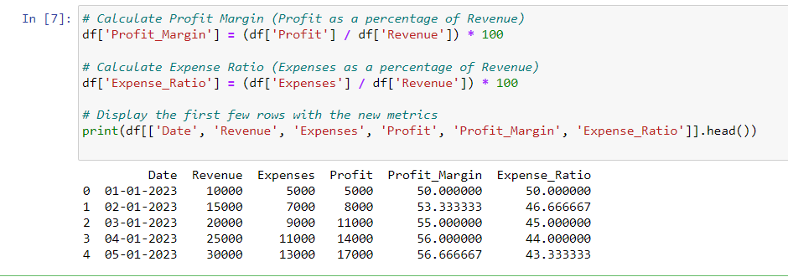

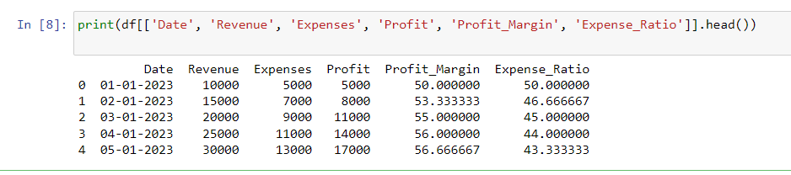

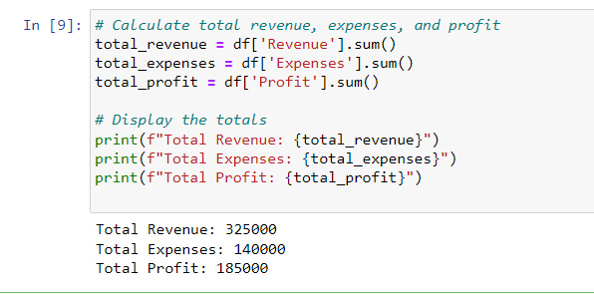

Task 4,5 & 6: Power BI Dashboard on the database:

Power BI dashboard Link: <https://skilluptech-my.sharepoint.com/:u:/g/personal/gouravs_skillup_online/EQcLykqQNA5OmjE_hB4lE6sBoqybpIzG8MN1G9-B9eotpw?e=mQCceK>